

Don’t let your memes be dreams. Or so said the illustrious Abraham Lincoln before John Wilkes Booth invaded his private booth (has no one seen this irony before?). That’s an important message I believe we could all benefit from this week, with the spectre of end of term exams looming, assessments incoming, and the imminent invasion of our illustrious hall by Unilodge. So good luck this week, and remember, a meme is only a meme when it is no longer in your dreams.

*Doing it for Bill since 2014*

THE BRUCE BILLITIN

**ISSUE 11: Monday 2ndMay – Sunday 8th May**

*Doing it for Bill since 2014*

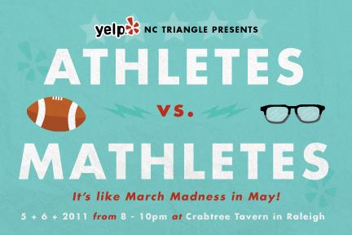

CANBERRA INTERNATIONAL MUSIC FESTIVAL

**Various venues, Continues for entire week**

A music festival aimed at making us all that bit more cultured. Described as a vibrant fusion of expertly curated music and iconic performances both daring and intimate, this is definitely something not to miss for those musically inclined among you. For the full concert and event calendar, head to [www.cimf.org.au](http://www.cimf.org.au).

LOCAVORE WORKSHOP: The Art of Natural Beer Brewing

**7th May 10am – 1pm YMCA Bush Capital Lodge**

Feeling like exams are the yeast of your problems? Then head down to this craft-brewing workshop and join National Champion Homebrewer Kevin Hingston as he takes you for a morning of all things beer and brewing. Bookings are essential, so head to [www.ecoaction.com.au/events/](http://www.ecoaction.com.au/events/) for more info.

TREE WEEK  
**All week at the National Arboretum**

This week is tree week, and that means it’s time to branch out and leaf your worries behind! The Friends of the National Arboretum invite you to come and celebrate autumn with a variety of activities. There will be guided walks to see the best of our autumn colours, as well as Tree Week talks from expert guest speakers. Head to [www.nationalarboretum.act.gov.au/visit/](http://www.nationalarboretum.act.gov.au/visit/) for more info.

MOTHER’S DAY CLASSIC  
**8th May 8-11am Commonwealth Park**

An annual fun run and walk raising funds and awareness for breast cancer research. It aims to deliver an inspirational event that brings the community together on Mother’s Day to support and remember those touched by breast cancer. Entry is not free, but you can book online at mdc.mothersdayclassic.com.au.

WHY WE NEED BATMAN: The Politics, philosophy and popularity of the caped crusader  
**5th May 6-6:45pm Coombs Lecture Theatre**

Yes, this was in the Billitin last week, but it’s Batman, and so should be in it every week (hmmmm….). Basically a lecture about why Batman is awesome and explaining why this is so, while exploring what he has to teach us about contemporary politics and conflict. Essentially why should you go? Because…. HE’S BATMAAAAAAANNNNNN

GRAVITATIONAL WAVES AND EINSTEIN: Explaining the binary black hole system discovery event  
**6-7.15pm 5th May Llewellyn Hall**

A public lecture from three members of the LIGO scientific collaboration, the team which discovered gravitational waves, will discuss this discovery, its history and its implications.

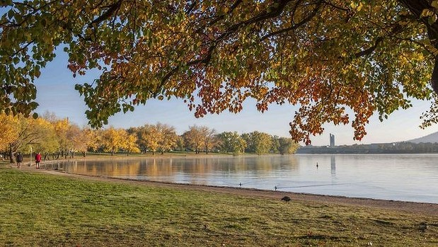

*Do Something, She Says….* – Blinky Bill





BUDGET NIGHT WITH HARRY & RILEY

**Budget night is a night for celebration. A night which ushers in multiple jokes by lefty lecturers at the expense of us poor PPE students, only for us to then use them as ammunition for our next buttery night costume. And so, as perennial budget night enthusiasts, we have collated a select couple of events at which you can party like it’s 1989 and the HECS debt hasn’t dropped!**

* **ANUSA Budget Night Party**Held in the Brian Kenyon Student Space, this favourite of both liberal and labour hacks will be sure to be one to get rowdy and bring your party poppers to. Prepare yourselves to smile and wave at multiple witty political jokes (oh Bill Shorten, you comic you) and endure a lengthy diatribe on the failure of our politicians by a 1st year economics student.
* **Parliament House Budget Release**Why not go down to the big one itself? With this budget set to focus on tax cuts and superannuation changes, why not use your newfound funds to take the public transport. As we know ‘poor people don’t have cars’ and neither should you. Thanks Joe Hockey.
* **Budget Watch-Party 2016**Whats more fun than laughing at the plebians who fail to thank you enough for being rich and taking the weight of the economy? Joining the proletariat and launching a grassroots revolution of course! Come join the local unionists at the Wig & Pen pub in union court for such fun activities as ‘budget bingo’. Who said that communism isn’t fun?
* **If you don’t laugh you Cry –Budget Party**With such an attractive name, who wouldn’t want to go to this party at the Nishi Gallery? Apparently these people don’t have any influence, but do have an open bar, and that makes all the difference.

While these events are all important, budget night is inevitably overshadowed by the birthday of someone who holds a special place in my heart …. Niccolo Machiavelli, the master of PPE. So please, on budget night, spare a thought for **all** the noble people born on that day.

INTERHALL SPELLING BEE  
**4TH May 7:30pm Burgmann College**

The time has come for this years interhall spelling bee! Come support our very own spellers Jack Vaughan, Roland Rousselot and Cherry Zheng as they avoid all bee-related puns and lists of reasons to do things.

MATHLETES & ATHLETES: Unilodge and Bruce Buttery Night  
**5th May 8pm Buttery**

Join everyone in the buttery for some of Lachie Matthew’s infamous butt stuff, some interhall shenanigans, and the ever hilarious combination of mathletes and athletes! Here is a chance to show off our creativity and ability to look either like a massive nerd, or a massive jock (or some weird hybrid combination of the two, go wild). It’s sure to be a great night, with food and drinks aplenty, so come on up!

ITALIAN CULTURAL WEEKEND  
**6-8th May various locations around Bruce**

So you think you can be Italian? Do you think your understanding of the finer points of Italian food and culture don’t escape you? Then prepare to be surprised in this cultural extravaganza when we avoid stereotypes by making pizza, playing soccer and watching the Godfather! There will also be a Da Vinci code style scavenger hunt, which is sure to get those noggins going. It’s going to be a busy, roman-tic, and most of all fun weekend, so keep your eyes peeled on both the event pages and banter for more info!



MEMORIAL SERVICE  
**3rd May 7:30pm Packard Dining Hall**

Friends and Family are respectfully invited to reflect on and share memories of Oleksandr in this memorial service to celebrate his life.

1. 9, 2. Austria, 3. Fly, 4. 1860’s, 5. Elizabeth Bennet, 6. Claude Monet, 7. Sweden, 8. 1995, 9. Michael Phelps, 10. Sarabi

TRIVIA

1. How many non-animated batman films have been made? 6. Who was the founder of French Impressionist painting?

2. In which country is Liechtenstein Castle located? 7. Which country did ABBA represent at Eurovision?

3. Houdini was the third person to do what across Australia in 1910? 8. When was the last time a team other than Manchester

4. In what decade was the Kingdom of Italy formed as a single United, Arsenal, Chelsea or Manchester city won the   
 country? English Premier league?

5. What is the name of the main character in Jane Austen’s Pride 9. Which athlete has won the most Olympic medals?  
 and Prejudice? 10. What was Simba’s mother’s name in the Lion King?